**LAB 7: Explanations of 3NF Tables**

For a table to be in 3NF:

It means that it should have a composite primary key (a primary key consisting of more than one attribute) and all non-key attributes must be fully functionally dependent on the entire composite primary key.

No transitive dependencies: A table is in 3NF if it does not have any transitive dependencies. A transitive dependency occurs when one non-key attribute depends on another non-key attribute, which in turn depends on the primary key. To eliminate transitive dependencies, we need to ensure that all non-key attributes are directly dependent on the entire primary key.

| Primary Key | Foreign Key |
| --- | --- |

Address Table

| Address ID | Street Number | Street Name | City | Province | County | Postal Code |
| --- | --- | --- | --- | --- | --- | --- |

**{Address ID (PK)} →** {Street Number**,** Street Name, City, Province, Country, Postal Code}

**{Country} →** {City, Province, Country, Postal Code}

**{Province} →** {City}

EXPLANATION:

This table is not in 3NF because we have some non-key attributes depending on other non-key attributes (transitive dependencies). In order to make the table to 3NF, there are a couple of methods, but we chose to do the Bernstein algorithm that was shown in class. After removing all the redundancies, decomposing and creating tables that satisfy the 3NF conditions, we would have the following three tables.

Address Table

| Address ID | Street Number | Street Name | County |
| --- | --- | --- | --- |

Country Table

| Country | Province | Postal Code |
| --- | --- | --- |

Province Table

| Province | City |
| --- | --- |

And below we have shown the work done using the Bernstein Algorithm to make the Address table to 3NF.

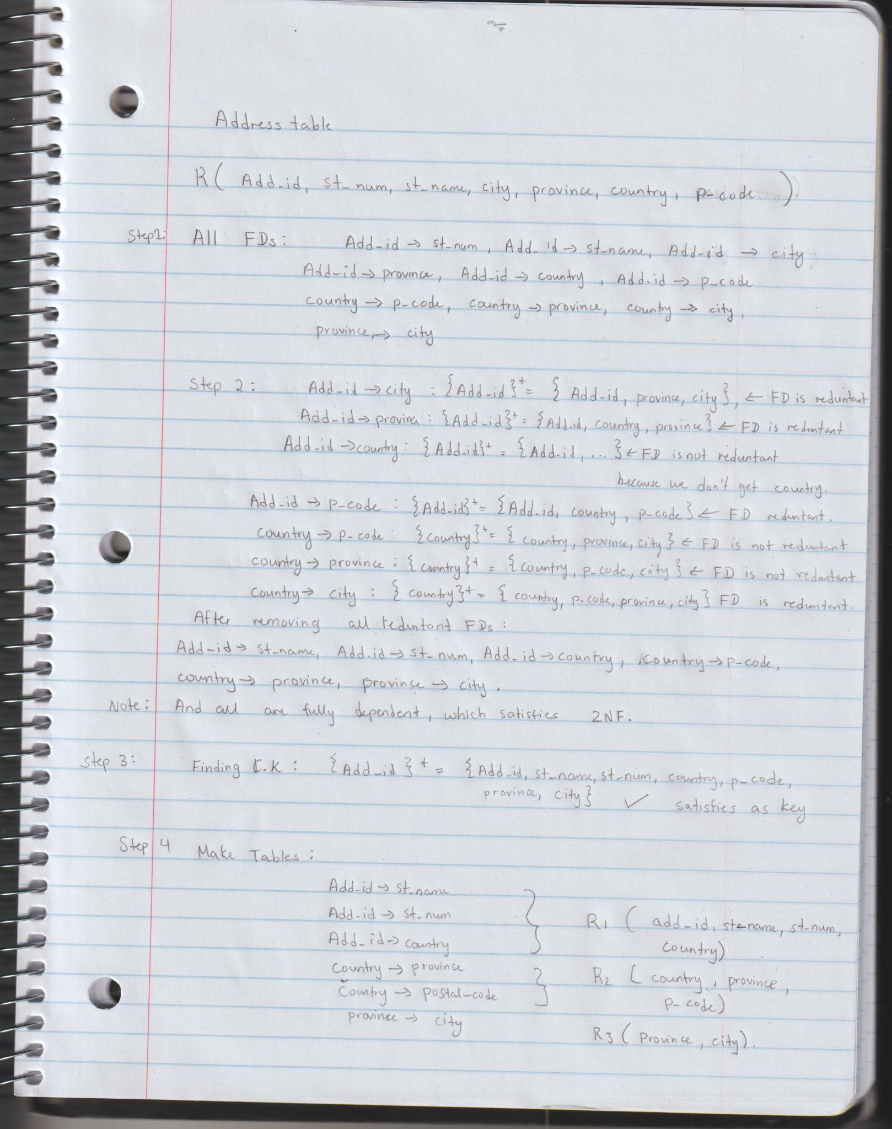

Customer Table

| Customer ID | Address ID | Username | Password | Email | First Name | Last Name | Phone Number |
| --- | --- | --- | --- | --- | --- | --- | --- |

**{Customer ID (PK)} →** {Username, Password, Email, First Name, Last Name, Phone Number, Address ID}

EXPLANATION:

This table is in 3NF already because we have a primary key (CUSTOMER ID), and all other non-key attributes depend on CUSTOMER ID. It also does not have any transitive dependencies because no non-key attribute depends on another non-key attribute. The foreign key ADDRESS ID helps break down transitive dependencies.

Product Table

| Product ID | Product Name | Product Desc | Price | Stock | Image URL |
| --- | --- | --- | --- | --- | --- |

**{Product ID (PK)} →** {Product Name, Product Dec, Price, Stock, Image URL}

EXPLANATION:

This table is in 3NF already because we have a primary key (PRODUCT ID), and all other non-key attributes depend on PRODUCT ID. It also does not have any transitive dependencies because no non-key attribute depends on another non-key attribute.

Category Table

| Category ID | Category Name |
| --- | --- |

**{Category ID (PK)} →** {Category Name}

EXPLANATION:

This table is in 3NF already because we have a primary key (CATEGORY ID), and all other non-key attributes depend on CATEGORY ID. It also does not have any transitive dependencies because no non-key attribute depends on another non-key attribute.

Product Category Table

| Product Category ID | Product ID | Category ID |
| --- | --- | --- |

**{Product Category ID (PK)} →** {Product ID, Category ID}

EXPLANATION:

This table is in 3NF already because we have a primary key (PRODUCT CATEGORY ID), and all other non-key attributes depend on PRODUCT CATEGORY ID. It also does not have any transitive dependencies because no non-key attribute depends on another non-key attribute. the foreign keys PRODUCT ID and CATEGORY ID help break down transitive dependencies.

Order Table

| Order ID | Customer ID | Address ID | Order Date | Order Time | Total Price |
| --- | --- | --- | --- | --- | --- |

**{Order ID (PK), Customer ID, Address ID} →** {Order Date, Order Time, Total Price}

EXPLANATION:

This table is in 3NF already because we have a primary key (ORDER ID), and all other non-key attributes depend on ORDER ID. It also does not have any transitive dependencies because no non-key attribute depends on another non-key attribute. The foreign keys CUSTOMER ID and ADDRESS ID help break down transitive dependencies.

Order Item Table

| Order Item ID | Order ID | Product ID | Quantity | Subtotal |
| --- | --- | --- | --- | --- |

**{Order Item ID (PK), Order ID, Product ID} →** {Quantity, Subtotal}

EXPLANATION:

This table is in 3NF already because we have a primary key (ORDER ITEM ID), and all other non-key attributes depend on ORDER ITEM ID. It also does not have any transitive dependencies because no non-key attribute depends on another non-key attribute. The foreign keys ORDER ID and PRODUCT ID help break down transitive dependencies.

Shopping Cart Table

| Customer ID | Creation Time | Creation Date |
| --- | --- | --- |

**{Customer ID (PK)} →** {Creation Time, Creation Date}

EXPLANATION:

This table is in 3NF already because we have a primary key (CUSTOMER ID), and all other non-key attributes depend on CUSTOMER ID. It also does not have any transitive dependencies because no non-key attribute depends on another non-key attribute.

Cart Product Table

| Cart Product ID | Customer ID | Product ID | Quantity |
| --- | --- | --- | --- |

**{Cart Product ID (PK), Customer ID, Product ID} →** {Quantity}

EXPLANATION:

This table is in 3NF already because we have a primary key (CART PRODUCT ID), and all other non-key attributes depend on CART PRODUCT ID. It also does not have any transitive dependencies because no non-key attribute depends on another non-key attribute. The foreign keys CUSTOMER ID and PRODUCT ID help break down transitive dependencies.